**Alert Conditions**

**The system is up and running :**

1. Host is down :  
   Sends an alert if Atlas is unable to reach a host for several minutes.  
   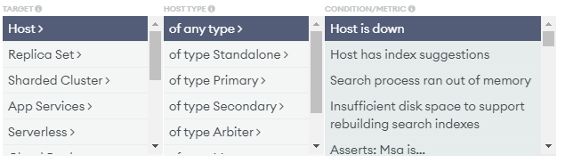

**The system performance is not degrading:**

**Memory** :The following alert conditions measure memory for a MongoDB process, as collected from the MongoDB serverStatus command's mem document

1. System Memory: Used is : (RAM)   
   Sends an alert if system memory usage meets the specified threshold.  
   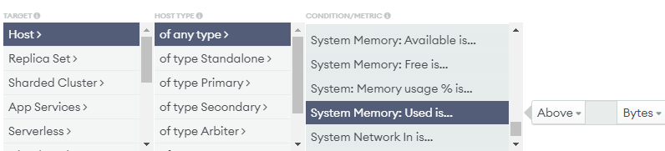
2. System Memory: Free is :  
   Sends an alert if the amount of free system memory drops below the specified threshold.  
   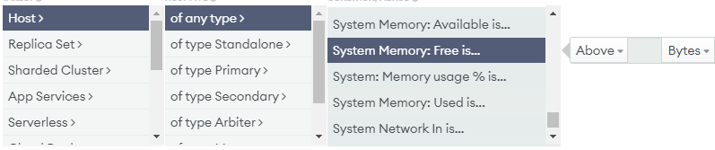
3. System Memory: Available is :   
   Sends an alert if the amount of available system memory drops below the specified threshold  
   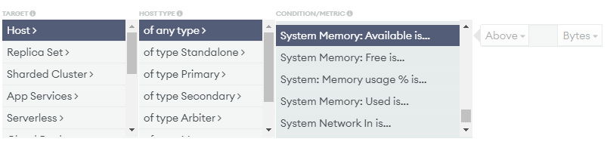
4. Memory: Resident is :  
   Sends an alert if the size of the resident memory meets the specified threshold. It is typical over time, on a dedicated database server, for the size of the resident memory to approach the amount of physical RAM on the box.  
   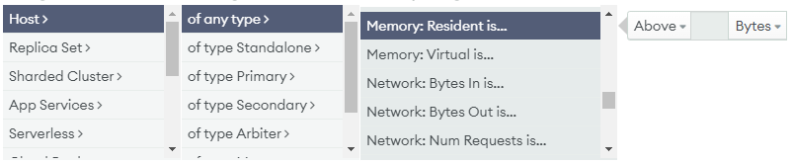
5. Search Memory: Resident is :  
   Sends an alert if the total bytes of resident memory occupied by the Atlas Search process is above or below the threshold.  
   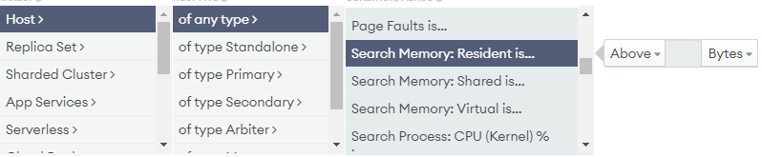
6. Search Memory: Shared is :  
   Sends an alert if the total bytes of shared memory occupied by the Atlas Search process is above or below the threshold.  
   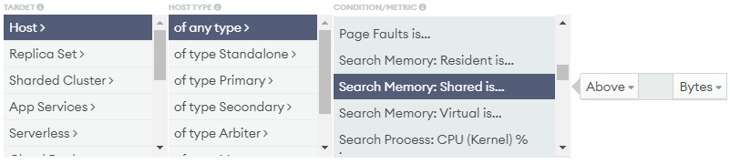

**we are not running out of eitSher disk space or computed power**

**DB Storage** :The following alert conditions apply to database storage, as collected for a MongoDB process by the MongoDB dbStats command.

1. DB Storage is :  
   Sends an alert if the allocated storage meets the specified threshold. This alert condition can be viewed on a host's DB Storage chart, accessed through cluster monitoring.  
   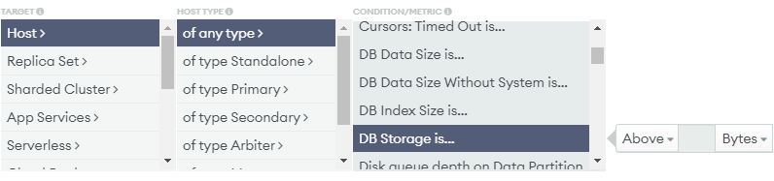

**Price & billing**

1. Credit card is about to expire :  
   Sends an alert if the credit card on file is about to expire. The alert is triggered at the   
    beginning of the month that the card expires.Atlas enables this alert when a credit card is added for the first time.  
   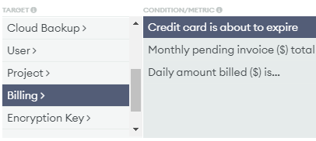
2. Daily amount billed($) is... :  
   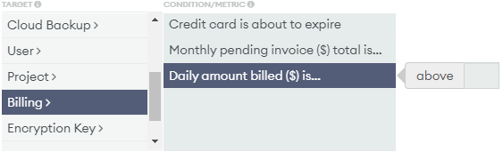
3. Monthly pending invoice($) total is ...:  
   